An Analysis of Chinese Traditional Patterns in Mobile Game Interface of Chinese Style
-A Case Study of Fantasy Westward Journey-

Rongfang Zhang, Donghyuk Choi

Department of Visual Contents, Division of Digital Contents
Graduate School of Dongseo University, Dongseo University
Busan, South Korea
faigazrf@gmail.com, artistar@dongseo.ac.kr

Abstract

This paper analyzes the history and cultural background of Chinese traditional patterns, and how Chinese traditional patterns are used in mobile game. Through these studies, the research results of the use of Chinese traditional patterns in the field of games have been obtained, which will provide valuable reference materials for the research on game market and game design. The traditional Chinese pattern is an important product of the traditional Chinese culture which has been developing with the Chinese history for thousands of years, and is the crystallization of the wisdom of the Chinese nation. With the rapid development of the world's game industry, Chinese style mobile games have a large share of mobile game market. A large number of Chinese traditional patterns are used as decorations in Chinese style mobile game. But research into the use of traditional Chinese patterns in mobile games is inadequate. Therefore, this paper, with Fantasy Westward Journey as example, analyzes the use and value of Chinese traditional patterns in the mobile game interface of Chinese style.

Keywords-chinese traditional patterns; mobile Game; interface

I. Introduction

Since the primitive society, Chinese traditional patterns have been incorporated into our life with their unique shapes for thousands of years. In recently years, mobile games get an increasing number of users, among which games in Chinese style are popular with the players. Mobile game Fantasy Westward Journey, which was launched on 26th March, 2015, topped the lists of top-free and bestseller both in iPhone and iPad during a short period. So far, it still ranks the top five in App Store and in 2016, it was awarded the best-selling mobile game in App Store. The present paper focuses on the interfaces of Fantasy Westward Journey and analyzes the application of Chinese traditional patterns on the interfaces of this game.
The present paper aims to tap into the functions and features of traditional patterns in designing mobile games and investigate the relationship between traditional culture and mobile games. The present paper firstly explores the origins and functions of Chinese traditional patterns and analyzes the concept and themes of mobile games in Chinese style. Secondly, this paper investigates the historical and cultural background of Fantasy Westward Journey and summarizes the patterns frequently used in it. Finally, this paper analyzes the patterns applied on the interfaces of Fantasy Westward Journey and their features.

II. Theoretical Research

Chinese traditional patterns are ornamental patterns with rich Chinese ethnic features, which are inherited form various ages. From the primitive society to the feudal society, Chinese traditional patterns have always existed and changed with the development of economy, politics and culture. They partly reflect people’s customs and values in a particular period[1].
Mobile games in Chinese style refer to games containing Chinese characters and Chinese traditional cultural elements such as traditional fine arts, music and weapons. With Xiyou, Sanguo, Wuxia and Xianxia as four major themes, mobile games in Chinese style account for a large proportion in China’s mobile game market.

TABLE I
Categories of mobile games in Chinese style
according to their themes
Theme | Popular Games |  | Features
Xiyou | 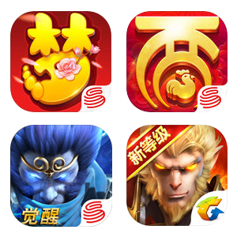 | Xiyou mobile games refer to games adapted from Journey to the West, one of the four great classical novels of Chinese literature. Characters in such games usually use the characters in Journey to the West, such as Sun Wukong, Tang Seng, Zhu Bajie, Sha Seng, Longnv and Longtaizi.
Sanguo | 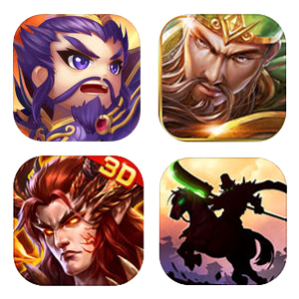 | With the period of Three Kingdoms as their historical background, Sanguo mobile games have three major camps—Shu Kingdom, Wei Kingdom and Wu Kingdom. Characters in such games mainly are officials and generals from those three camps, such as Liu Bei, Zhang Fei, Guan Yu, Zhuge Liang, Cao Cao, Lv Bu, Sun Quan and Zhou Yu.
Wuxia | 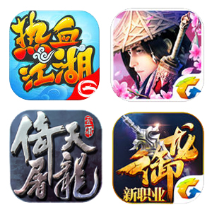 | Most of the Wuxia mobile games are against the background of stories from Wuxia novels. There are no immortals and ghosts in those games, with Wu and Xia as their cores. In the game world, players will quell the evil, embrace the good and help the weak as warriors.
Xianxia |  | More fantastic than Wuxia mobile games, Xianxia games have more characters including immortals, humans, goblins, demons or ghosts. In this kind of games, cultivation is the main story. Players will obtain various magic weapons and fairies during their upgrades.

III. Case Analysis

3.1. Overview of Fantasy Westward Journey
Fantasy Westward Journey, based on the original client game Fantasy Westward Journey II, is an RPG mobile game developed by NetEase Games. On 30th March, 2015, this game opened up its public beta on all platforms. It is operated by NetEase Games in China and is free for players.
Continually applying the background and setting of the original client game, Fantasy Westward Journey optimizes its settings according to the features of smart phones and restores six classic characters(Including Jianxiake, Gujingling, Longtaizi, Hutouguai, Wumaner and Xuan Caie) as well as classic elements such as escorting in transportation and haunting ghosts. At the same time, typical systems on the client game, such as systems of faction, business or mentoring marriage have been transferred on the mobile one.

3.2 Chinese traditional patterns applied on the interfaces of the Fantasy Westward Journey
Chinese traditional patterns are largely used as ornaments on the interfaces of Fantasy Westward Journey. The most frequently used patterns are Hui pattern, Cloud pattern, Ruyi Head pattern, Chinese dragon pattern and scroll grass pattern.
Hui pattern is a geometrical pattern shaped like the Chinese character “回”, deriving from thunder patterns on potteries and bronzes. Curved lines on the Hui pattern mean “endless wealth”. Therefore, the Hui pattern is usually used to decorate borders of the interfaces or serve as under-painting of the interfaces when combined with other patterns.
Cloud pattern, which is depicted according to the shape of clouds on the sky, can be classified into patterns of one-head cloud, two-head cloud, three-head cloud, cloud in hook, drifting cloud and so on. On the interfaces of this game, the Cloud pattern often decorates the edges of titles and buttons.
Ruyi head pattern derives from the ancient mascot Ruyi, the symbol of “good luck”. This pattern is applied to decorate boarders of subtitles and darkstripes of the four corners of the interfaces. It is usually designed as Back button or Page button because it has a sharp corner.
Scroll grass pattern refers to pattern with numerous grasses outlined by smoothing and winding ripple lines. Transformed from the stretching of plant branches and stems, this pattern is smooth and winding with diverse types of patterns. The scroll grass pattern is an auxiliary ornament which serves as decoration of borders of the icons or under-painting of the interfaces when combined with other patterns.
Chinese dragon is the totem of Chinese nation, the auspicious animal in ancient China and the symbol of power. As the most influential traditional pattern that has been long accepted by Chinese, Chinese dragon pattern can be classified, according to the dragons’ postures, into patterns of encircling dragon, sitting dragon, walking dragon, cloud dragon, curled-up dragon and double dragons playing with a peal, etc [2]. In this game, Chinese dragon pattern is often used as decorations of interfaces of achievements or awards.

TABLE II
Chinese traditional patterns applied
on Fantasy Westward Journey
Name | Pictures | positions on interface
Hui pattern | 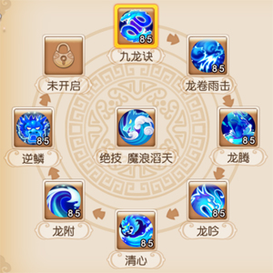 | under-painting  & borders of interfaces
Cloud pattern |  | the edges of  titles & buttons
Ruyi Head pattern | 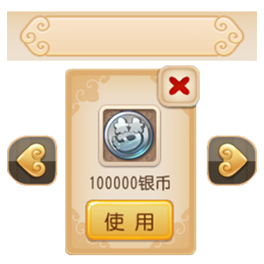 | boarders of subtitles; under-painting of interfaces;  Back button;  Page button
Scroll grass pattern | 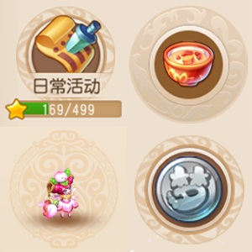 | borders of icons; under-painting of interfaces
Chinese dragon pattern | 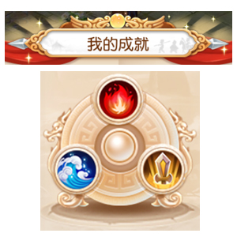 | boarders of titles on interfaces;  decoration of controls

Traditional patterns applied for decoration are rich but not complicate, which don’t overshadow the role of the interface. Using the same color as the interface, those traditional patterns are perfectly integrated into the interface, which enriches the details but doesn’t make players feel inappropriate. They make the interface more interesting and beautiful, heighten the atmosphere of Chinese style on the whole game and put players personally into the scene.

V. Conclusion

The present paper explores the meanings and origins of Chinese traditional patterns and analyzes the concept and themes of mobile games in Chinese style. Selecting Fantasy Westward Journey as the analytical focus, this paper analyzes the applications of Chinese traditional patterns on the interfaces of the game and draws the following conclusions.
Applied as ornaments, Chinese traditional patterns are usually used on the borders and under-painting on the interfaces. Patterns with special meanings are often used on special interface, for example, Chinese dragon pattern, the symbol of power, is often used on interfaces of achievements, awards and upgrades. The colors of those traditional patterns are same as the main colors of the interfaces, which enriches the details but doesn’t make players feel inappropriate, at the same time, doesn’t hinder their receiving information. The applications of those traditional patterns add interest and beauty to the interface, heighten the atmosphere of the whole game, implicate the historical background and optimize the user experience of their players.
Chinese traditional patterns and mobile games are a two-way street. One the one hand, without the application of those traditional cultural elements, Fantasy Westward Journey wouldn’t have been successful. One the other hand, the success of this game introduces Chinese traditional culture to more domestic players and players all over the world. The combination of the traditional culture and modern entertainment plays an important role in the inheritance and development of the traditional culture. Therefore, more profound researches should be conducted on relevant fields.
The present paper would be a good reference to the design of games and other diversified visual arts.

References

[1] Gu Yue, Traditional Chinese Patterns, Bei Jing:The Eastern Press, 2010.01, pp. 1-14
[2] Song, Ji Sung,Shi,Jin Min, “A Correlation Research on Consistency between Chinese Traditional Pattern and Brand Identity Design”, Journal of the Korean Society of Design Culture 17(2), 2011.06, pp. 288-289
[3] Joe, Hyun-Jee,“A Study of Traditional Pattern in Animation :focusing on Toom Moore’s 〈Song of Sea〉 and 〈SKahlil Gibran’s The Prophet: On Love〉 ”Korean Society of Cartoon and Animation Studies, 2016.06, pp. 1-26
[4] Xue Ji Xiang, “Application and Value of Chinese traditional patterns in the game design”,College Of Digital Arts, Shanghai University, 2015.04, pp. 7-14
[5] Ha Young Song, “A Development of Jacquard Fabric Design for Packaging Using Korean Traditional Patterns”, Journal of the Korean Society of Design Culture 20(1), pp. 7-8
[6] Hyun Jung Ryu, “Formative Characteristics and Aesthetic on Pattern Featured in Korean, Chinese and Japanese Traditional Dress”, Journal of the Korea Fashion & Costume Design Association 12(2), 2010.06, pp. 1-13

